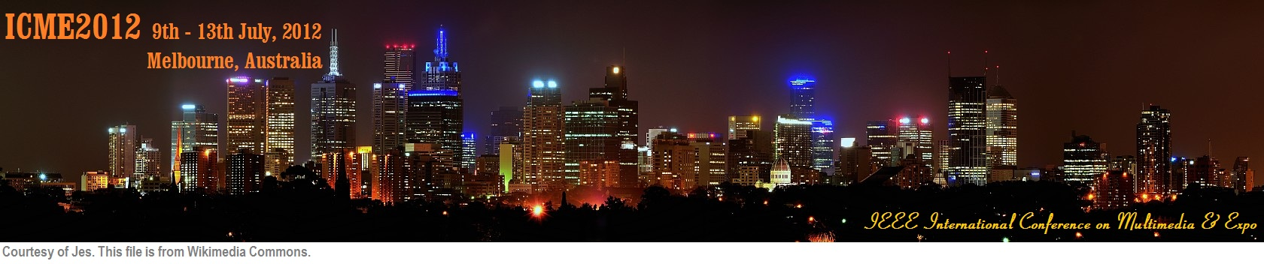

|  |
| --- |
| **IEEE International Conference on Multimedia & Expo Call for Workshop Proposals  July 9-13, 2012, Melbourne, Australia**  Workshop proposals are solicited for [ICME 2012](http://www.icme2012.org/). The workshops should be clearly focused and facilitating active discussions and constructive interactions on current or emerging topics of interest. They should allow members of the community to compare and discuss approaches, methods, and new concepts on research topics pertinent to the main conference. These topics often offer emerging interests to the multimedia research community or bridge the community with other areas.  Workshop proposals for ICME 2012 should include:   * The title, goals, and duration of the workshop (half-day or full-day, which will be held either on 9th or 13th July, 2012); * The specific topics that will be addressed by the workshop; * The relevance and significance of this workshop to the main conference; * The history of the workshop if it is not the first version; * A draft workshop call for papers with: * the names, affiliations, email addresses, and short bios of the workshop organizers, who should be experts in the related topics and preferably from multiple institutions; * the paper selection process; * a list of potential Program Committee members and their affiliations.   Workshop proposals should not exceed four pages and should be submitted to the Workshop Chairs, Jorge E. Caviedes (jorge.e.caviedes [AT] intel.com) and Tao Mei (tmei [AT] microsoft.com). Workshop proposals will be evaluated based on various criteria including the quality and level of details of the proposal, the theme of the workshop, its relevance to the main conference, and the overall balance of the conference workshop program.  Important Dates:   * Workshop proposal submission: Oct. 15, 2011 * Proposal acceptance: Nov. 15, 2011 * Workshop paper submission: March 5, 2012 * Workshop paper acceptance: March 26, 2012 * Workshop camera ready: April 9, 2012   Workshop Co-chairs:   * Jorge E. Caviedes (jorge.e.caviedes [AT] intel.com), Intel Corporation, USA * Tao Mei (tmei [AT] microsoft.com), Microsoft Research Asia, China   Main conference email: icme2012@icme2012.org  Main conference website: http://www.icme2012.org/ |